**Deploy Python App**

**Step 1 : Describe services**

# kubectl get deployment



**Step 2 : expose the application behind load balancer**

# kubectl expose deployment python-deployment --type="LoadBalancer"

# kubectl describe service python-deployment

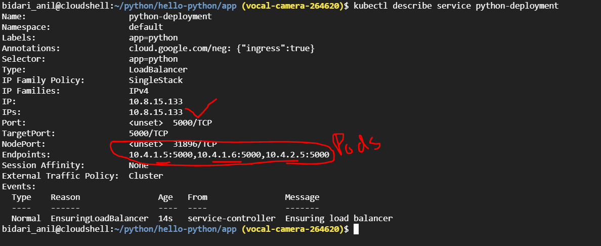

**Step 3 : Describe svc**

# kubectl get svc

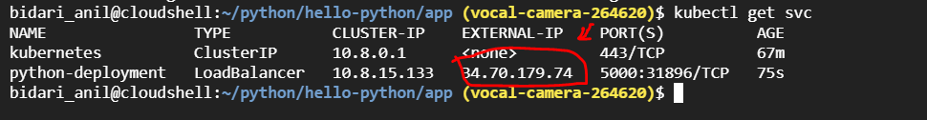

Use the External-ip:5000 on your web browser to verify app is running



============================ completion of Lab =======================================